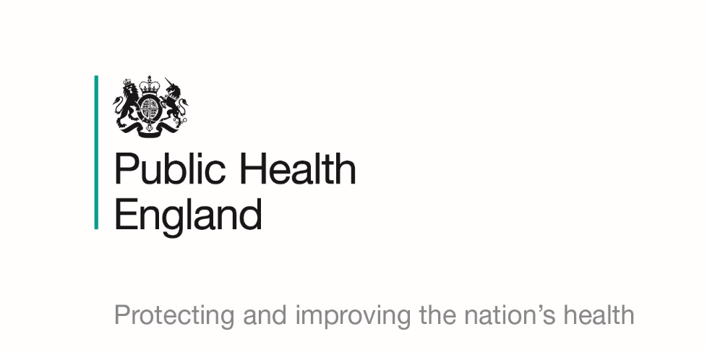

The National Disease Registration Service

Frequently Asked Questions

January 2020

About Public Health England

Public Health England exists to protect and improve the nation’s health and wellbeing, and reduce health inequalities. We do this through world-leading science, research, knowledge and intelligence, advocacy, partnerships and the delivery of specialist public health services. We are an executive agency of the Department of Health and Social Care, and a distinct delivery organisation with operational autonomy. We provide government, local government, the NHS, Parliament, industry and the public with evidence-based professional, scientific and delivery expertise and support.

Public Health England  
Wellington House

133-155 Waterloo Road  
London SE1 8UG  
Tel: 020 7654 8000  
[www.gov.uk/phe](http://www.gov.uk/phe)   
Twitter: [@PHE_uk](https://twitter.com/PHE_uk)

Facebook: [www.facebook.com/PublicHealthEngland](http://www.facebook.com/PublicHealthEngland)

For queries relating to this document, please contact: ndrengagement@phe.gov.uk

UK-Ogl-symbol

© Crown copyright 2020  
You may re-use this information (excluding logos) free of charge in any format or medium, under the terms of the Open Government Licence v3.0. To view this licence, visit [OGL](https://www.nationalarchives.gov.uk/doc/open-government-licence/version/3/). Where we have identified any third party copyright information you will need to obtain permission from the copyright holders concerned.

Published May 2020   
PHE publications PHE supports the UN

Sustainable Development Goals

**[](https://www.gov.uk/government/collections/sustainability-and-public-health-a-guide-to-good-practice)**

Contents

What is collected and why…………………………………………………4

Data confidentiality and security…………………………………………..6

Data Sharing…………………………………………………………………8

Opting out…………………………………………………………………….9

Patient Access………………………………………………………………10

What is collected and why

1. **What is cancer registration and who collects my information?**

The NHS has been collecting cancer data since 1947. Since then, it has made great strides in understanding what causes cancer, and how to best diagnose and treat it. This has only been possible due to a process called cancer registration. Today, the quality, scale and accuracy of the information held by UK cancer registries is unmatched anywhere in the world.

When a person is diagnosed with cancer or a condition that may lead to cancer, the NHS team looking after them will record information about them, the cancer diagnosis and the treatment they receive. This applies to children and adults. This information is shared with the cancer registry and a cancer registration record is created.

Each country in the UK has its own cancer registry that receives and stores patient information.

For England it is the National Cancer Registration and Analysis Service (NCRAS), which is a part of Public Health England (PHE) (<https://www.gov.uk/government/organisations/public-health-england/about>).

For Wales it is the Welsh Cancer Intelligence and Surveillance Unit (WCISU) which is a part of Public Health Wales (PHW) (<https://phw.nhs.wales/about-us/>).

For Scotland it is the Scottish Cancer Registry and Intelligence Service (SCRIS) which is a part of NHS Scotland’s Information Services Division (ISD) (<https://www.isdscotland.org/About-ISD/>).

For Northern Ireland it is the Northern Ireland Cancer Registry (NICR) which is hosted by Queen’s University Belfast (<https://www.qub.ac.uk/research-centres/nicr/AboutUs/Registry/>).

1. **What is the National Cancer Registration and Analysis Service (NCRAS)?**

The National Cancer Registration and Analysis Service (NCRAS) is England’s cancer registry. It is part of Public Health England (PHE) and is responsible for collecting information about cancer patients from the NHS. NCRAS uses this information to track new and existing cancer cases. The data helps to identify possible causes of cancer, effective treatments and improve NHS services. Only by collecting information from as many people as possible can the cancer registry help healthcare teams to decide on the most effective care and treatment for patients.

1. **Do I need to register to have my information included on the cancer registry?**

No, you do not need to register to have your information included on the cancer registry. NCRAS has the government’s permission to collect patient data without informed consent because it is in the public interest to improve the way cancer is diagnosed and treated.

When you are diagnosed with cancer or a condition that may lead to cancer, information about your care and treatment is recorded by the NHS team looking after you. This information is updated automatically and securely shared with NCRAS who use it to support work to improve public health, healthcare and research. Patient information continues to be collected as a person receives further care. You have the right to opt out of cancer registration if you do not want your information collected. See page 9 for more details.

1. **What information does NCRAS record about my cancer?**

NCRAS stores information such as the type of cancer you have, where it is in your body, and whether it has spread to any other parts of the body. NCRAS also keeps information about your treatment and how well your treatment is working. This information helps to drive improvements in preventing, diagnosing and treating cancer.

1. **What personal information does NCRAS hold about me?**

NCRAS receives your name, date of birth, sex, ethnic background, NHS number and address from the NHS. This is used to match healthcare records to the correct person.

Your email address and phone number will not be recorded. PHE receives details about the address where you lived at the time of your diagnosis as this helps to identify cancer risks that might be in the surrounding environment. If you have moved since your diagnosis, details of your new address are not stored.

1. **Why does NCRAS collect my data and how is it used?**

NCRAS holds information on all cancers across England because using this data to conduct research to improve cancer outcomes is so important to public health.

It is used to improve research, understand cancer, improve treatment, evaluate policy, improve diagnosis, plan NHS services and improve genetic counselling. The information may also be used by healthcare staff to see if you would benefit from participating in a clinical trial.

We also know that some types of cancer run in families. Your doctor will tell you if this is true for your cancer. With your permission, doctors can use your information to see if other members of your family may be at risk, and find the best ways to treat them. You may also be referred to a genetic counsellor to think through what this means for you and your family.

Monitoring cancer is also an international effort. Collecting data helps us to compare what is happening to cancer patients in England with what happens elsewhere in the world.

Data confidentiality and security

1. **How is my information kept safe?**

Cancer registration is an established system and has made important contributions to public health. NCRAS takes its responsibility as a data guardian very seriously and has put a range of measures in place over the years to make sure your information is held securely and shared responsibly.

Staff access and processing:

* The information is collated and handled by specially trained cancer registry staff who have been vetted and operate under the strictest of controls. They do not have access to personally identifiable information unless it is needed to match healthcare records to the correct person.
* Cancer registration teams across England work in special secure areas in Public Health England offices which can only be accessed by people with permission to work with personal data. No-one else is allowed in these rooms unless they are escorted and have signed a strict confidentiality agreement.
* The data is used by analysts, but most of them do not see personally identifiable data. Analysts who do have access to personally identifiable data must have specific permission and work in a secure, specially designated office space.

Technology measures:

* Data is sent from the NHS to the cancer registry via protected systems. The cancer registry applies encryptions and strong passwords to the information it holds and follows the guidelines on looking after patient data, as set by the National Data Guardian (<https://www.gov.uk/government/organisations/national-data-guardian/about>)
* NCRAS servers are held securely within PHE and are accessible only from a secure designated NHS network, known as N3. Servers are kept in locked server rooms with limited access. All NCRAS data systems are subject to Public Health England's security policies.
* Security procedures are also regularly reviewed to make sure that all systems are up to date and the most secure. This helps to protect the information about you.

External data sharing:

* Data is turned into statistics which are aggregate and anonymous, and do not identify an individual.
* Data that is released outside of NCRAS is controlled by Public Health England's Office for Data Release (ODR), which puts in place strict technical and contractual controls to prevent unauthorised access to the data.

1. **Is the information on the cancer register made public and can my personal details be seen on it?**

No, the cancer register is not made public.

Internal staff including registration officers and analysts have access to your data under strict controls. This is for research and quality assurance purposes such as improving patient outcomes and service design, and understanding treatments, demographics and regional variations.

External organisations such as university and industry researchers, charities, and government offices can apply to access data from the cancer registry for authorised uses. These requests are considered by the Office for Data Release (<https://www.gov.uk/government/publications/accessing-public-health-england-data/about-the-phe-odr-and-accessing-data>) – see page 8 for more information about how data is shared.

1. **How is NCRAS able to collect my cancer information without my consent?**

NCRAS has been granted legal permission to collect patient information without consent under Section 251 of the National Health Service Act 2006 (<https://www.legislation.gov.uk/ukpga/2006/41/section/251>)This is because collecting information to improve cancer research is important for public health. It allows the common law duty of patient confidentiality to be set aside to protect the public’s health and monitor risks. Our permissions are reviewed on a yearly basis by the Confidentiality Advisory Group (<https://www.hra.nhs.uk/about-us/committees-and-services/confidentiality-advisory-group/>). You have the right to opt out of cancer registration if you do not want your information collected. See page 9 for more details.

Data sharing

1. **Who has access to my information in Public Health England and more widely? How is this decided?**

In Public Health England, cancer registration officers and some of the analysts have access to your data under strict conditions and for specific reasons, such as matching healthcare records to the correct person. Any staff member accessing patient data will work in a secure area where visitors and unauthorised staff cannot access unless escorted.

Patient data is also shared with external parties such as researchers who must follow the same strict access process. PHE also applies the Caldicott Principles (<https://www.igt.hscic.gov.uk/Caldicott2Principles.aspx>) to make sure they only provide the minimum amount of data necessary. Data is only released to research organisations who use it for a medical purpose to help patients and the public. It is never sold for commercial purposes or released for marketing and insurance reasons.

1. **Is data used outside of NCRAS?**

Yes, the data can be used outside of NCRAS.

The Office for Data Release (ODR) is responsible for responding to requests to access NCRAS data. All requests are reviewed by the ODR to assess whether the data will be used appropriately, ethically, legally, for research, and will not place patient confidentiality at risk. When an external organisation is given access to patient data, they must adhere to data release contracts that are legally binding and strictly control how the data is used. The data must be kept secure and destroyed after a certain period of time. Most of the data released to external organisations is anonymous, unless an applicant has special permission to access personally identifiable data. In this case, the applicant must justify why their research requires access to identifiable data and have individual patient consent or a legal basis to access it.

Data is made publicly accessible in different forms such as official and national statistics, reports and online tools, but it is combined to make sure that it does not contain any information that could be used to identify individual patients.

For more information, please visit the Understanding Patient Data website for an explanation about anonymisation (<https://understandingpatientdata.org.uk/what-does-anonymised-mean>).

Opting out

1. **What if I do not want my data to be collected?**

If you do not want NCRAS to collect and use your data you have the right to opt-out of cancer registration. Please see question 2 for more information.

1. **How do I opt out of having my information included in NCRAS?**

You have the right to opt-out of cancer registration. If you decide to opt-out it will not affect the quality of care you receive. If you no longer want your information to be included in the cancer registry, you can contact us at [optout@phe.gov.uk](mailto:optout@phe.gov.uk) or you can write to:

Director

National Cancer Registry

Public Health England

6th Floor, Wellington House

133-155 Waterloo Road

London, SE1 8UG

For more information about opting out of cancer registration, please visit: (<https://www.ndrs.nhs.uk/national-disease-registration-service/patients/opting-out/>)

1. **What are the potential implications of opting out?**

If more people choose to opt out of cancer registration, then its information will become less complete and less reliable.

Opting out of cancer registration may have implications for you personally and your relatives. If you choose to opt out, you may not be notified about important developments that may benefit or impact you, or we may not be able to identify you as being at risk in future patient notification exercises. For example, NHS England uses NCRAS information to identify women at risk of breast cancer due to having radiotherapy for Hodgkin Lymphoma when they were younger.

Although most cancers are not inherited, some people have a higher risk of developing certain cancers. Families with these genes typically have family members who develop similar types of cancer at a younger than would be expected. If you choose to opt out, we may also be unable to assess the genetic risk of your family developing cancer.

Patient access

1. **How can I see the information NCRAS holds about me?**

You have the right to see the information that NCRAS holds about you. If you would like to do this you can apply for something known as a Subject Access Request (<https://ico.org.uk/your-data-matters/your-right-to-get-copies-of-your-data/>). NCRAS will send your information to your GP or the clinician treating you who will then show it to you. This happens so they can confirm your identity and make sure that someone else is not attempting to access your records. Your GP or clinician can help to explain anything that is unclear, but they will not view your information without your consent.

1. **My relative has a history of cancer. Can I see the information NCRAS holds about my family members?**

No, you cannot see the information that NCRAS holds about your relatives, including any children you may have. If you are worried about your family’s medical history and believe you are at increased risk of developing cancer, you should ask your GP who may refer you for genetic testing. Please see our website for more information: (<https://www.ndrs.nhs.uk/national-disease-registration-service/congenital-anomalies-and-rare-diseases/genetic-requests/>).

1. **Can NCRAS tell me or my family if we have a genetic risk of developing cancer?**

You should talk to your GP if you are worried about a history of cancer in your family. If you are thought to be at increased risk your doctor may refer you for genetic testing. NCRAS can provide details of cancer diagnoses within a family to geneticists and genetic counsellors to understand if someone is at increased risk of developing cancer. PHE receives around 30,000 requests each year from geneticists and genetic counsellors on behalf of patients in their care.

For more information about genetic requests, please visit the NDRS website: (<https://www.ndrs.nhs.uk/national-disease-registration-service/congenital-anomalies-and-rare-diseases/genetic-requests/>).

1. **How can I contribute to the work of NCRAS?**

The quality, scale, and accuracy of the cancer data shared with NCRAS is unmatched anywhere in the world. By keeping your data in the cancer registry, you are already contributing to the work of NCRAS. Without patient data we would not be able to carry out the vital research needed to understand the prevalence and incidence of cancer, and improve care and treatment for patients.

If you would like to contact us about getting involved or making further contributions, please get in touch at [NDRengagement@phe.gov.uk](mailto:NDRengagement@phe.gov.uk)

1. **Where can I find out more information about my own cancer?**

More information is available through the NHS website (<https://www.nhs.uk/conditions/cancer/>).

More support is available through some of our partner organisations:

* Cancer 52 - <https://www.cancer52.org.uk/>
* Macmillan Cancer Support - <https://www.macmillan.org.uk/>
* Cancer Research UK - <https://www.cancerresearchuk.org/>